ANANDA VIDYALAYA MATRIC HR. SEC. SCHOOL
ZONAL WINNERS – 2024-25
GAMES
BOYS
Handball | U-14, U-17, U-19 | Winner
Tenni koit | U-14 (S & D) | Runner up

GIRLS
Handball | U-19 | Winner
Tenni koit | U-17 (S & D) | Runner up
Table tennis | U-14 (S) | Runner up
Table tennis | U-17 (S) | Runner up

ATHLETICS
BOYS
U 14
High Jump | P. Vishvajit | I
200 m | A.R.Purnesh | I
Shotput | A.R.Purnesh | I
4x100m Relay | M.A.Kingslin Joshua, V.Nithish Krishnan A.R.Purnesh, P. Vishvajit | II

U 17
High Jump | J.Jeya Vignesh | II
4x400m Relay | M.Harishkumar, J.Jeya Vignesh, K.Vasantha ganesh, A.G.Dinesh | II
100 m | K.Vasantha ganesh | III
4x100m Relay | G.Venkateshwaran, J.Jeya Vignesh, K.Vasantha ganesh, A.G.Dinesh | III

U 19
Javelin throw | S. Kaviarasu | II
800m | R. Vetrivel | II
4x100m Relay | R. Vetrivel. S.Kaviarasu, P.R.Ganesh, S.Nithish kumar | II
4x400m Relay | R. Vetrivel. V.Akash, P.R.Ganesh, S.Nithish kumar | II
100 m | S. Kaviarasu | III

GIRLS
U 19
High Jump | A. Soshuma | I

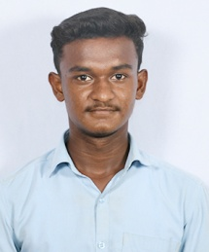

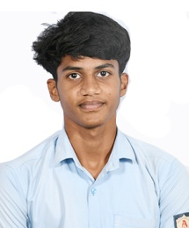
S. Kaviarasu - XII Std R. Vetrivel – XII Std

These Students have been selected to represent the Virudhunagar District Hand ball team and they have participated in the State Level Chief Minister Trophy tournament.
Virudhunagar District won the State level C.M. trophy and these students have received Rs.75,000/- each as cash award.

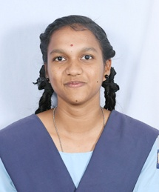
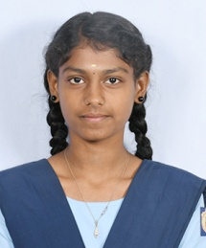

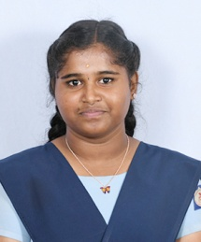
P.Balamaheswari - XII Std A. Soshuma – XII Std G. Sahana – XII Std

These Students have been selected to represent the Virudhunagar District Handball team and participated in the State level matches

