ANANDA VIDYALAYA MATRIC. HR. SEC. SCHOOL, RAJAPALAYAM.
TEACHERS DETAILS (2024-25)
Name : S. Gopala Krishnan (Principal)
Qualification: M.A., B.Ed.,(Economics)
Experience : 18 yrs

Classes handling : XII Std

Name : R. Revathi thilagam
Qualification: M.A., B.Ed.,(Social)
Experience : 23 yrs

Classes handling : VI to VIII Std

Name : M.Naguporchelvi
Qualification: M.Sc.,B.Ed.,(Zoology)
Experience : 21 yrs

Classes handling : X to XII Std

Name : M.Alagurani
Qualification: B.Sc.,M.A., B.Ed.,(Tam)
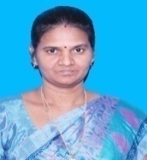
Experience : 21 yrs
Classes handling : VI to VIII Std


Name : M. Murugan
Qualification: M.Sc.,M.Phil.,(Chemistry)
Experience : 18 yrs
Classes handling : X to XII Std

Name : C. Rathinavel
Qualification: M.A., B.Ed.,(Tamil)
Experience : 17 yrs

Classes handling : IX to XII Std
;

Name : G. Kadalkani
Qualification: M.Sc., B.Ed.,(Physics)
Experience : 17 yrs

Classes handling : IX to XII Std

Name : P. Viji
Qualification: M.Sc., B.Ed.,M.Phil.,(Botany)

Experience : 17 yrs
Classes handling : IX to XII Std

Name : S.Jegadeswari
Qualification: M.Com.,B.Ed.,(Comm/Acc)
Experience : 16 yrs

Classes handling : XI & XII Std

Name : S. Kalidas
Qualification: M.Sc., B.Ed.,(Comp.Sci)
Experience : 16 yrs

Classes handling : XI to XII Std

Name : P. Vasanthi
Qualification: B.Sc., B.Ed.,(Sci)
Experience : 14 yrs

Classes handling : VI to X Std

Name : P. Sarojini
Qualification: B.Lit., B.Li.Sci,(Librarian)
Experience : 9 yrs

Classes handling : VI to X Std

Name : T. Kadal
Qualification: M.A., B.Ed.,(Tam)
Experience : 8 yrs
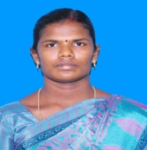
Classes handling : X to XII Std

Name : D. Nivedha
Qualification: M.A., B.Ed.,(Eng)
Experience : 11 yrs

Classes handling : IX to XI Std

Name : K. Padmavathi
Qualification: M.Com., B.Ed.,(Comm/ Comp.Sci)
Experience : 10 yrs

Classes handling : IX to XI Std

Name : M. Kalyanasundaram
Qualification: B.Sc.,(Maths)
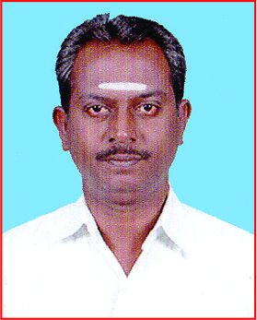
Experience : 10 yrs
Classes handling : VIII to X Std

Name : I. Paramasivam
Qualification: B.Sc.,M.P.Ed., M.Phil.,(Phy.En)

Experience : 9 yrs
Classes handling : VI to XII Std

Name : K.Rajkumar
Qualification: M.Sc, B.Ed.,(Maths)
Experience : 4 yrs
Classes handling : IX to XII Std


Name : M.S.P. Soabiyaa
Qualification: M.Sc,, B.Ed.,(Maths)
Experience : 2 yrs
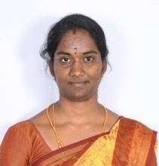
Classes handling : VI to VIII Std

Name : P. Jancy
Qualification: M.A, B.Ed.,(English)
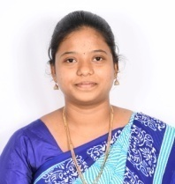
Experience : 2 yrs
Classes handling : X to XII Std

Name : V.Revathy
Qualification: M.A, B.Ed.,(English)
Experience : June 2024
Classes handling : Vo to IX Std
